Source code

Main Class
package airline;

public class AirlineReservation {

public static void main(String[] args) {

Manager manager= new Manager();

int mode=0;

while(mode!=4) {
mode=manager.Menu();
switch(mode){
case 1:
manager.Modify_flight();
break;
case 2:
manager.Modify_reservation();
break;
case 3:
manager.Report();
break;

}

}

manager.exit_program();
}

}
External Class - Manager
package airline;

import java.io.BufferedReader;
import java.io.BufferedWriter;
import java.io.FileReader;
import java.io.FileWriter;
import java.io.IOException;
import java.text.DecimalFormat;
import java.util.StringTokenizer;

import javax.swing.JOptionPane;

public class Manager {
public static int flightNumber[]= new int[100];
public static String flightOrigin[]= new String[100];
public static String flightDestination[]= new String[100];
public static String flightDate[]= new String[100];
public static String flightTime[]= new String[100];
public static int flightSeats[]= new int[100];
public static int reservationCode[]= new int[100];
public static int flight_NumberRes[]= new int[100];
public static String lastName[]= new String[100];
public static String firstName[]= new String[100];
public static String typeOfSeat[]= new String[100];
public static double costOfSeat[]= new double[100];
public static int count1=-1;
public static int count2=-1;
public static int flightCount;
public static int reservationCount;

Manager(){

Manager.flightCount=Read_flight();
reservationCount=Read_reservation();
}

public void Modify_flight() {
int selection;
String message="Modify Flight Information Menu\r\n" +
"1. Add Flight\r\n" +
"2. Delete Flight\r\n" +
"3. Modify Flight \r\n" +
"4. Exit this menu\r\n" +
"";
selection =Integer.valueOf(JOptionPane.showInputDialog(null, message,"",JOptionPane.QUESTION_MESSAGE));
switch(selection) {
case 1:
flightNumber[count1+1]=Integer.valueOf(JOptionPane.showInputDialog(null, "Enter Flight Number","Add Flight",JOptionPane.QUESTION_MESSAGE));
flightOrigin[count1+1]=JOptionPane.showInputDialog(null, "Enter Flight Origin","",JOptionPane.QUESTION_MESSAGE);
flightDestination[count1+1]=JOptionPane.showInputDialog(null, "Enter Flight Destination","Add Flight",JOptionPane.QUESTION_MESSAGE);
flightDate[count1+1]=JOptionPane.showInputDialog(null, "Enter Flight Date","Add Flight",JOptionPane.QUESTION_MESSAGE);
flightTime[count1+1]=JOptionPane.showInputDialog(null, "Enter Flight Time","Add Flight",JOptionPane.QUESTION_MESSAGE);
flightSeats[count1+1]=Integer.parseInt(JOptionPane.showInputDialog(null, "Enter Flight Seats","Add Flight",JOptionPane.QUESTION_MESSAGE));
count1++;

break;
case 2:

int k=0;
while(k<flightCount){
k++;
System.out.println(flightNumber[k]+" "+ flightOrigin[k]+" "+ flightDestination[k]+" "+ flightDate[k]+" "+flightTime[k]);

}
int eflight=Integer.valueOf(JOptionPane.showInputDialog(null, "Enter Flight Number","Delete Flight",JOptionPane.QUESTION_MESSAGE));
int index=-1;
for(int a=0;a<count1+1;a++) {
if(flightNumber[a]==eflight) {
index=a;

}

}

System.out.println("shit");
System.arraycopy(flightNumber, index + 1, flightNumber, index, flightNumber.length -1 - index);
System.arraycopy(flightOrigin, index + 1, flightOrigin, index, flightOrigin.length -1 - index);
System.arraycopy(flightDestination, index + 1, flightDestination, index, flightDestination.length -1 - index);
System.arraycopy(flightDate, index + 1, flightDate, index, flightDate.length -1 - index);
System.arraycopy(flightTime, index + 1, flightTime, index, flightTime.length -1 - index);
System.arraycopy(flightSeats, index + 1, flightSeats, index, flightSeats.length -1 - index);

break;
case 3:
int check=-1;
int editflight=Integer.valueOf(JOptionPane.showInputDialog(null, "Enter Flight Number","Edit Flight",JOptionPane.QUESTION_MESSAGE));
for(int a=0;a<count1+1;a++) {
if(flightNumber[a]==editflight) {
check=a;

}

}
String minmenu="Choose what you waant to edit \r\n" +
"1. Flight Origin\r\n" +
"2. Flight Destination\r\n" +
"3. Flight Date \r\n" +
"4. Flight Time\r\n" +
"5. Flight Seats\r\n" +
"";
int sel=Integer.valueOf(JOptionPane.showInputDialog(null, minmenu,"Choose option",JOptionPane.QUESTION_MESSAGE));
switch(sel) {
case 1:
flightOrigin[check]= JOptionPane.showInputDialog(null, "Enter Flight Origin","Edit Flight",JOptionPane.QUESTION_MESSAGE);

break;
case 2:
flightDestination[check]= JOptionPane.showInputDialog(null, "Enter Flight Destination","Edit Flight",JOptionPane.QUESTION_MESSAGE);
break;
case 3:
flightDate[check]= JOptionPane.showInputDialog(null, "Enter Flight Date","Edit Flight",JOptionPane.QUESTION_MESSAGE);
break;
case 4:
flightTime[check]= JOptionPane.showInputDialog(null, "Enter Flight Time","Edit Flight",JOptionPane.QUESTION_MESSAGE);
break;
case 5:
flightSeats[check]= Integer.valueOf(JOptionPane.showInputDialog(null, "Enter Flight Origin","Edit Flight",JOptionPane.QUESTION_MESSAGE));
break;

}

break;
case 4:
Menu();
break;
}

}

public void Modify_reservation() {
reservationCode[count2+1]=Integer.valueOf(JOptionPane.showInputDialog(null, "Enter Reservation Code","Add Reservation",JOptionPane.QUESTION_MESSAGE));
flight_NumberRes[count2+1]=Integer.valueOf(JOptionPane.showInputDialog(null, "Enter Flight Number","Add Reservation",JOptionPane.QUESTION_MESSAGE));
lastName[count2+1]=JOptionPane.showInputDialog(null, "Enter Last Name","Add Reservation",JOptionPane.QUESTION_MESSAGE);
firstName[count2+1]=JOptionPane.showInputDialog(null, "Enter First Name","Add Reservation",JOptionPane.QUESTION_MESSAGE);
typeOfSeat[count2+1]=JOptionPane.showInputDialog(null, "Enter Type of Seat","Add Reservation",JOptionPane.QUESTION_MESSAGE);
costOfSeat[count2+1]=Integer.valueOf(JOptionPane.showInputDialog(null, "Enter Cost of Seat","Add Reservation",JOptionPane.QUESTION_MESSAGE));
count2++;

}

public int Read_flight() {
try {
String content;
BufferedReader lineMaster= new BufferedReader(new FileReader("flightj.dat"));
while((content=lineMaster.readLine())!=null) {
StringTokenizer separator= new StringTokenizer(content,"#");
count1++;
flightNumber[count1]=Integer.parseInt(separator.nextToken());
flightOrigin[count1]=separator.nextToken();
flightDestination[count1]=separator.nextToken();
flightDate[count1]=separator.nextToken();
flightTime[count1]=separator.nextToken();
flightSeats[count1]=Integer.parseInt(separator.nextToken());

}
lineMaster.close();

} catch (IOException error) {

System.out.println("Error on file read: " + error);
}

return count1;
}

public int Read_reservation() {
try {
String content;

BufferedReader lineMaster= new BufferedReader(new FileReader("reservationj.dat"));
while((content=lineMaster.readLine())!=null) {
StringTokenizer separator= new StringTokenizer(content);
count2++;
reservationCode[count2]=Integer.parseInt(separator.nextToken("#"));
flight_NumberRes[count2]=Integer.parseInt(separator.nextToken("#"));
lastName[count2]=separator.nextToken("#");
firstName[count2]=separator.nextToken("#");
typeOfSeat[count2]=separator.nextToken("#");
costOfSeat[count2]=Double.parseDouble(separator.nextToken());

}
lineMaster.close();

} catch (IOException error) {
// TODO: handle exception
System.out.println("Error on file read: " + error);
}
return count2;
}
public void Report() {
DecimalFormat df = new DecimalFormat();
df.setMaximumFractionDigits(2);
int option=0;

while(option!=9) {
String menu= " Acme Airlines\n"
+"1. All flight Info\n"
+"2. All Reservation Info\n"
+"3. Value of reservations of a specific type\n"
+"4. All Reservations on a specific flight \n"
+"5. Report 5\n"
+"6. Report 6\n"
+"7. Report 7\n"
+"8. Report 8\n"
+"9. Exit Report Menu\n"
+"Please make your selection >";

option=Integer.parseInt(JOptionPane.showInputDialog(null, menu,"",JOptionPane.QUESTION_MESSAGE));
int k=0;
switch(option){
case 1:

while(k<flightCount){
k++;
System.out.println(flightNumber[k]+" "+ flightOrigin[k]+" "+ flightDestination[k]+" "+ flightDate[k]+" "+flightTime[k]);

}
break;
case 2:

while(k<count2){
k++;

System.out.println(reservationCode[k]+" "+ flight_NumberRes[k]+" "+ lastName[k]+" "+ firstName[k]+" "+typeOfSeat[k] +" "+ costOfSeat[k]);

}
break;
case 3:
String type;
type=JOptionPane.showInputDialog(null, "Enter type of seat","Reservations Check",JOptionPane.QUESTION_MESSAGE);
double totalAmount=0;
while(k<count2){
k++;
if(type.equals(typeOfSeat[k])) {
System.out.println(reservationCode[k]+" "+ flight_NumberRes[k]+" "+ lastName[k]+" "+ firstName[k]+" "+typeOfSeat[k] +" "+ costOfSeat[k]);
totalAmount+=costOfSeat[k];
}
}

System.out.println("\n The total value of reservations is: " + df.format(totalAmount));

break;
case 4:
int flightNo;
flightNo=Integer.valueOf(JOptionPane.showInputDialog(null, "Enter flight number","Reservations Check",JOptionPane.QUESTION_MESSAGE));
while(k<count2){
k++;
if(flightNo==flight_NumberRes[k]) {
System.out.println(reservationCode[k]+" "+ flight_NumberRes[k]+" "+ lastName[k]+" "+ firstName[k]+" "+typeOfSeat[k] +" "+ costOfSeat[k]);

}
}
break;
case 5:
int totalreservations=0;
String city= JOptionPane.showInputDialog(null, "Enter city","Search flights",JOptionPane.QUESTION_MESSAGE);
for(int a=0;a<count1+1;a++) {
if(flightOrigin[a].equals(city)) {

System.out.println(flightNumber[a]+" "+ flightOrigin[a]+" "+ flightDestination[a]+" "+ flightDate[a]+" "+flightTime[a]);
for(int b=0; b<count2+1;b++) {
if(flight_NumberRes[b]==flightNumber[a]) {
totalreservations++;
}
}
System.out.println("Total reservations fot his flight("+flightNumber[a]+") are: "+totalreservations);
totalreservations=0;
}

}
break;
case 6:
int reservation= Integer.valueOf(JOptionPane.showInputDialog(null, "Enter reservation code","Search flights",JOptionPane.QUESTION_MESSAGE));
for(int b=0; b<count2+1;b++) {
if(reservationCode[b]==reservation) {
System.out.println("Reservation details");
System.out.println(reservationCode[b]+" "+ flight_NumberRes[b]+" "+ lastName[b]+" "+ firstName[b]+" "+typeOfSeat[b] +" "+ costOfSeat[b]);
for(int a=0;a<count1+1;a++) {
if(flight_NumberRes[b]==flightNumber[a]) {
System.out.println("Flight details");
System.out.println(flightNumber[a]+" "+ flightOrigin[a]+" "+ flightDestination[a]+" "+ flightDate[a]+" "+flightTime[a]+ "\n\n");
}
}

}

}

break;
case 7:
for(int a=0;a<count1+1;a++) {
System.out.println("Flight details");
System.out.println(flightNumber[a]+" "+ flightOrigin[a]+" "+ flightDestination[a]+" "+ flightDate[a]+" "+flightTime[a]+"\n");

System.out.println("Reservation details");
for(int b=0;b<count2+1;b++) {
if(flight_NumberRes[b]==flightNumber[a]) {

System.out.println(reservationCode[b]+" "+ flight_NumberRes[b]+" "+ lastName[b]+" "+ firstName[b]+" "+typeOfSeat[b] +" "+ costOfSeat[b]);
}
}

System.out.println("\n");
}
break;
case 8:
String cityFlights=JOptionPane.showInputDialog(null, "Search for flight out of and into a city\n Enter a city below","Search flights",JOptionPane.QUESTION_MESSAGE);
for(int a=0;a<count1+1;a++) {
if(flightOrigin[a].equals(cityFlights)|| flightDestination[a].equals(cityFlights)) {
System.out.println(flightNumber[a]+" "+ flightOrigin[a]+" "+ flightDestination[a]+" "+ flightDate[a]+" "+flightTime[a]+"\n");
}
}
break;

}
}
}
public int Menu() {
int selection=0;
String display=" ACME Airline System\n"
+ "1. Add/modify Flight information\n"
+ "2. Add/modify Reservation information\n"
+ "3. Report Section\n"
+ "4. Exit Airline System\n\n"
+ "Please make your selection>";
String input =JOptionPane.showInputDialog(null, display,"",JOptionPane.QUESTION_MESSAGE);;
selection= Integer.parseInt(input);
return selection;

}
public void exit_program() {

try {
BufferedWriter flightMaster= new BufferedWriter(new FileWriter("flightj.dat"));
for(int a=0;a<count1+1;a++) {
flightMaster.write(flightNumber[a]+"#"+ flightOrigin[a]+"#"+ flightDestination[a]+"#"+ flightDate[a]+"#"+flightTime[a]);
flightMaster.newLine();

}
flightMaster.close();
BufferedWriter reserveMaster= new BufferedWriter(new FileWriter("reservationj.dat"));
for(int b=0;b<count2+1;b++) {
reserveMaster.write(reservationCode[b]+"#"+ flight_NumberRes[b]+"#"+ lastName[b]+"#"+ firstName[b]+"#"+typeOfSeat[b] +"#"+ costOfSeat[b]);
reserveMaster.newLine();
}
reserveMaster.close();

} catch ( IOException e) {
// TODO Auto-generated catch block
System.out.println(e.toString());
e.printStackTrace();
}
}
}

Screenshots
Modify Flight
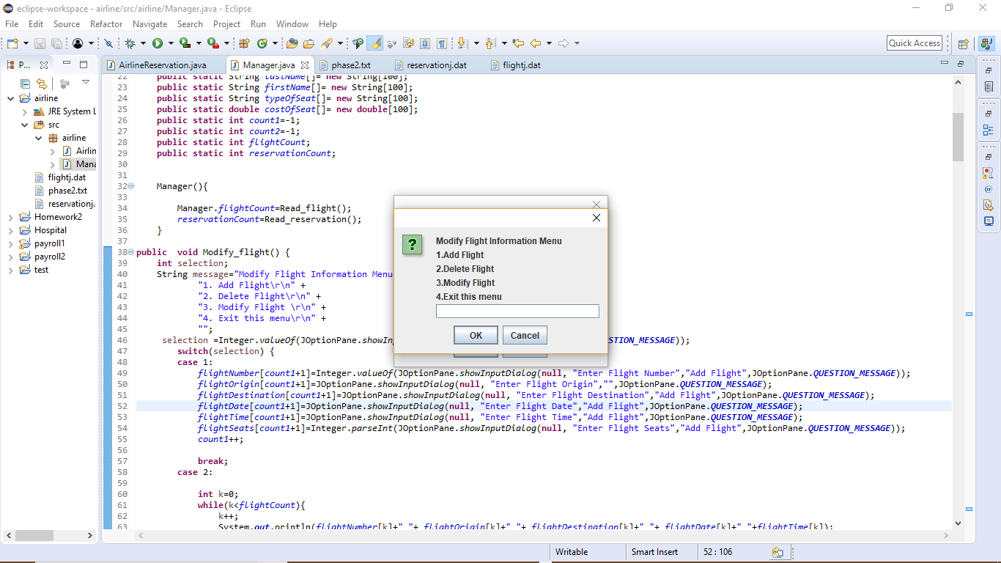
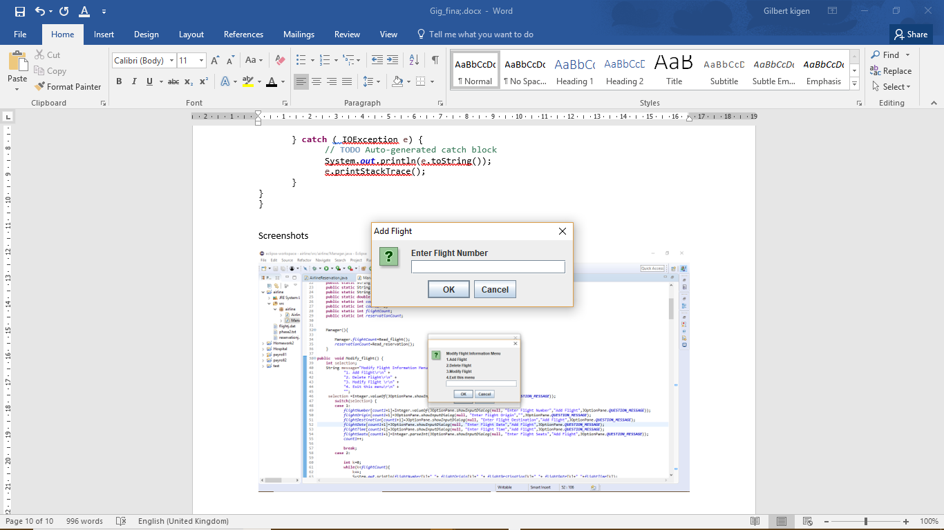

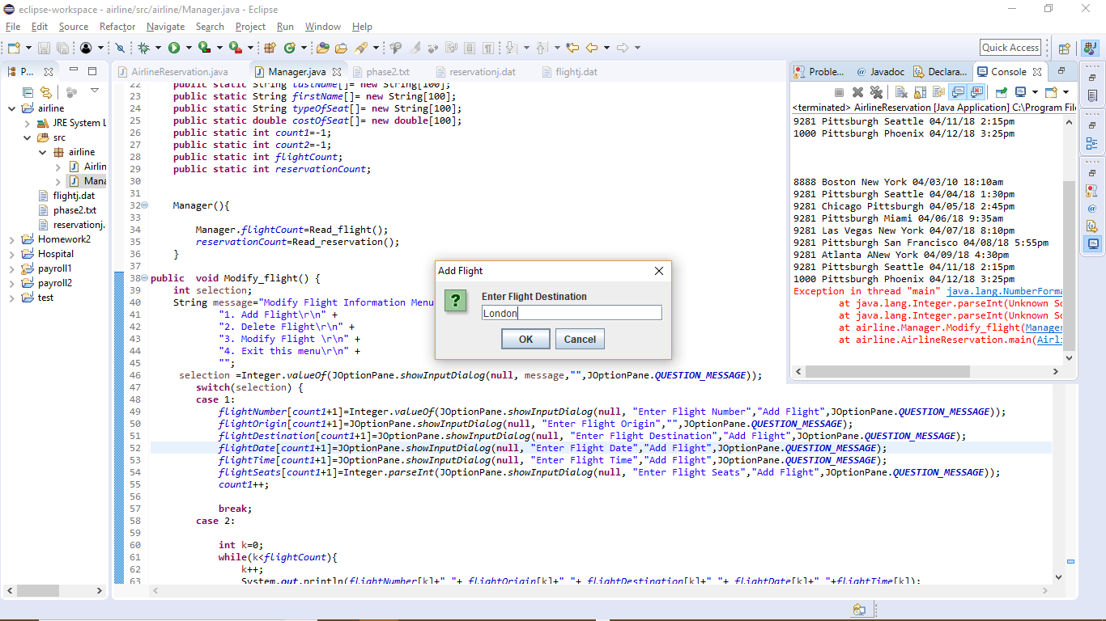
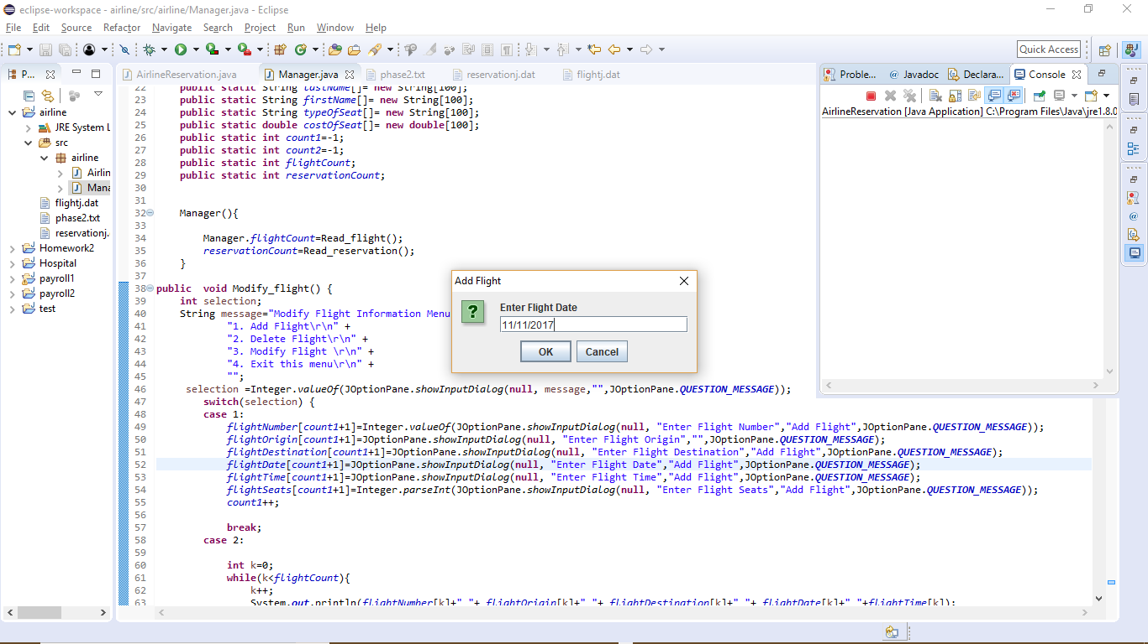
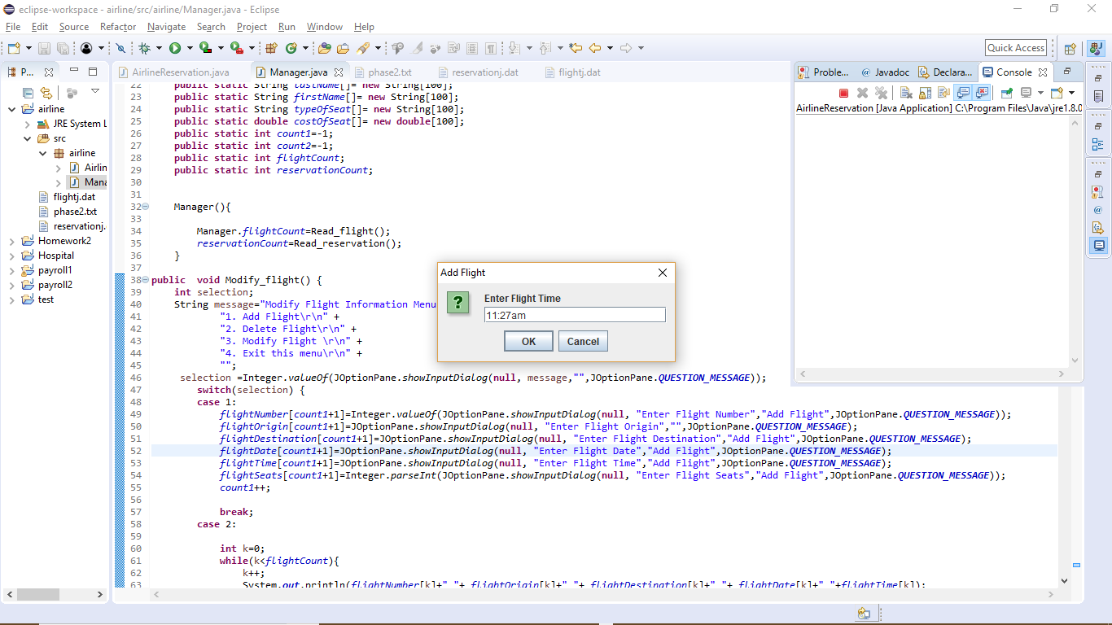
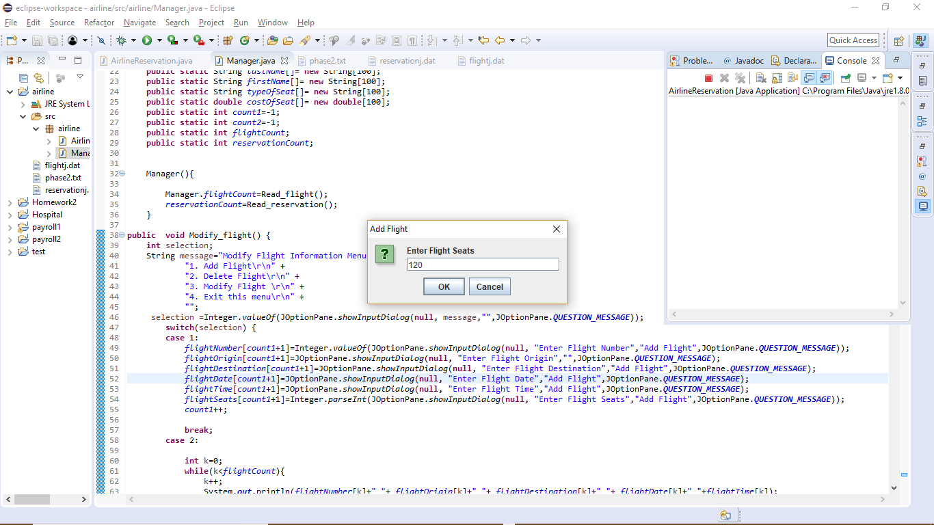
Modify Reservation
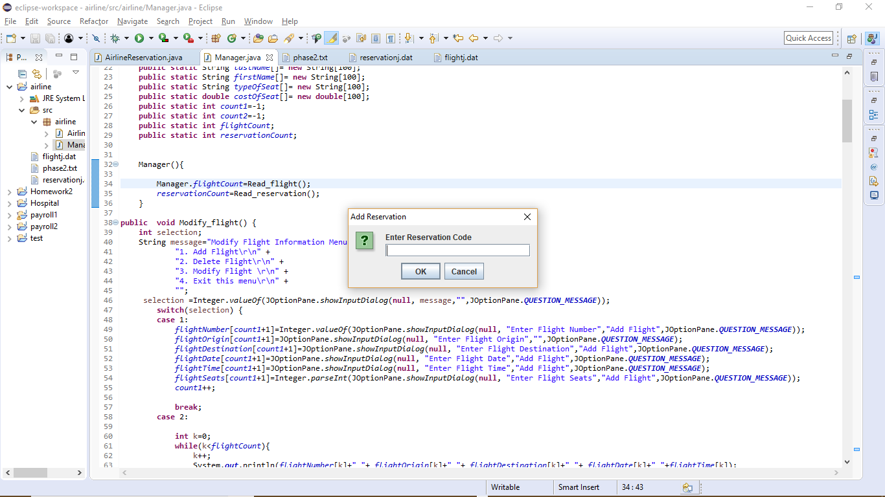
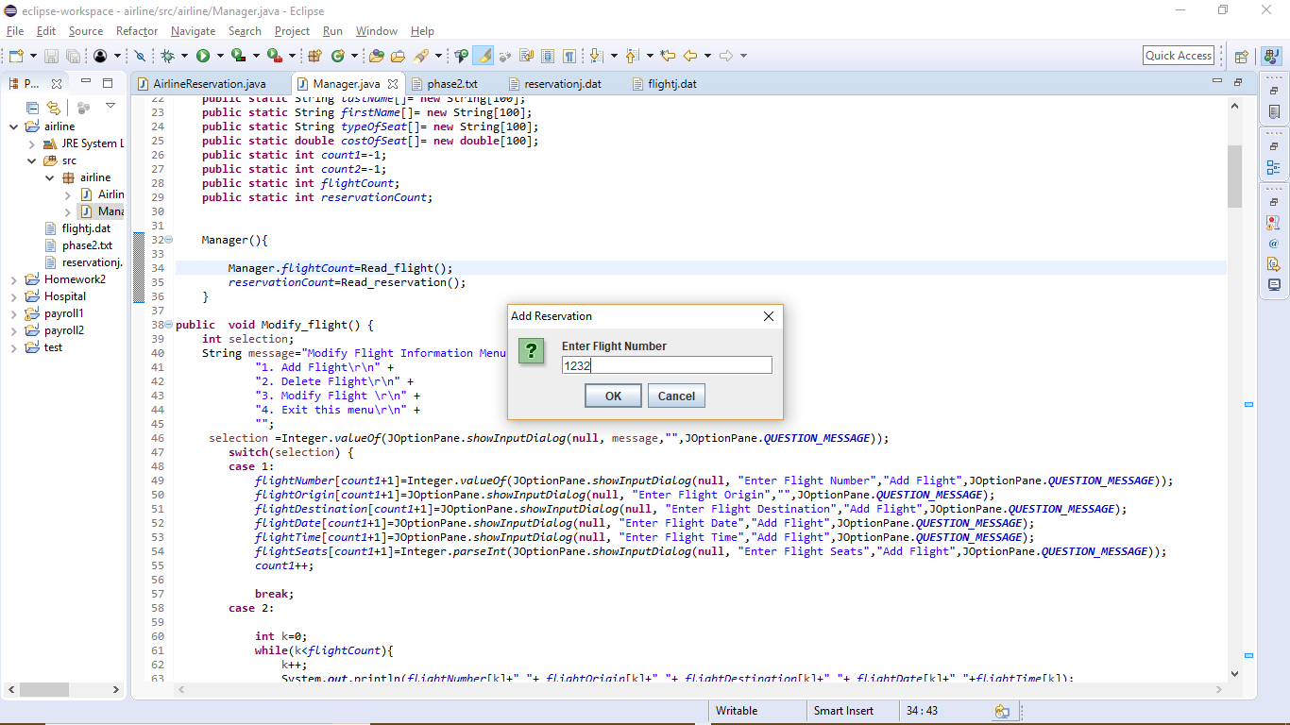
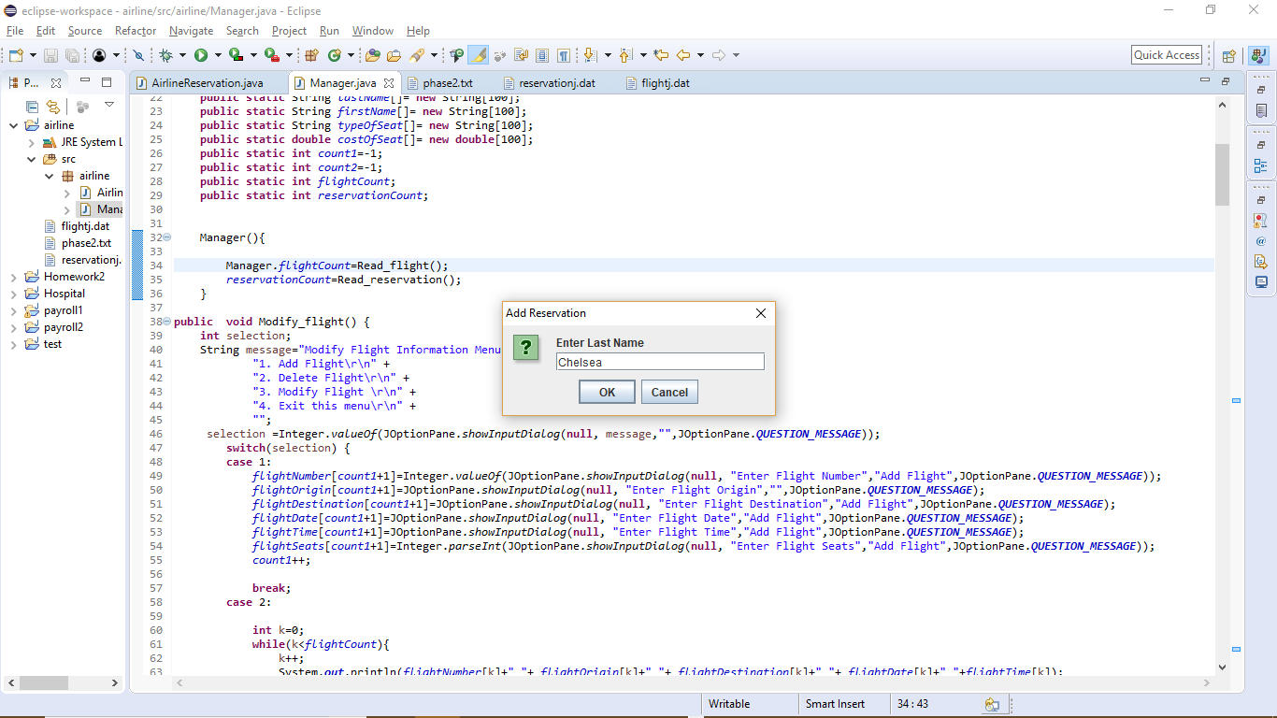
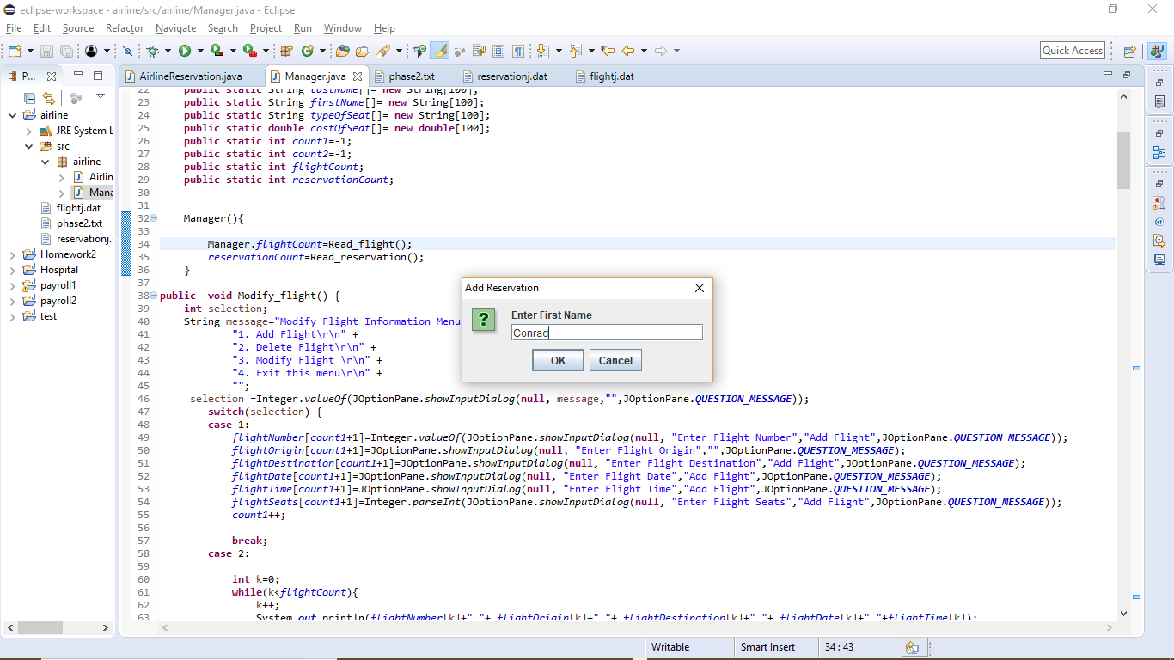
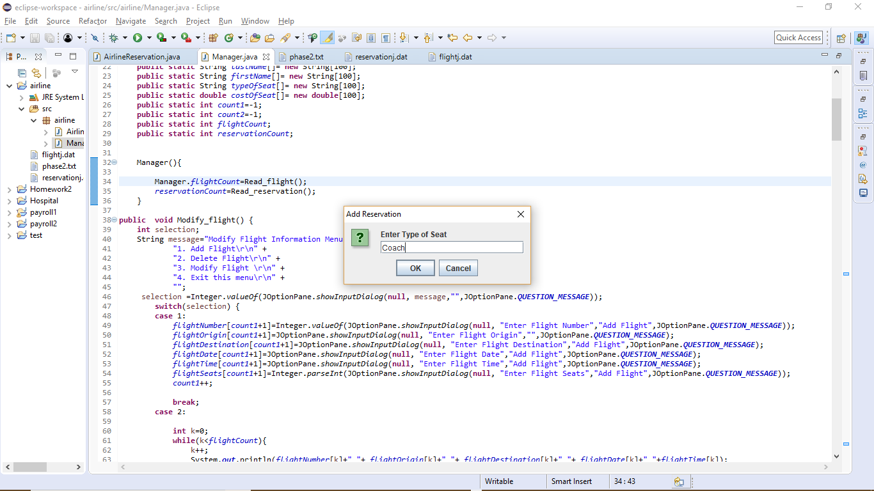
Report 5
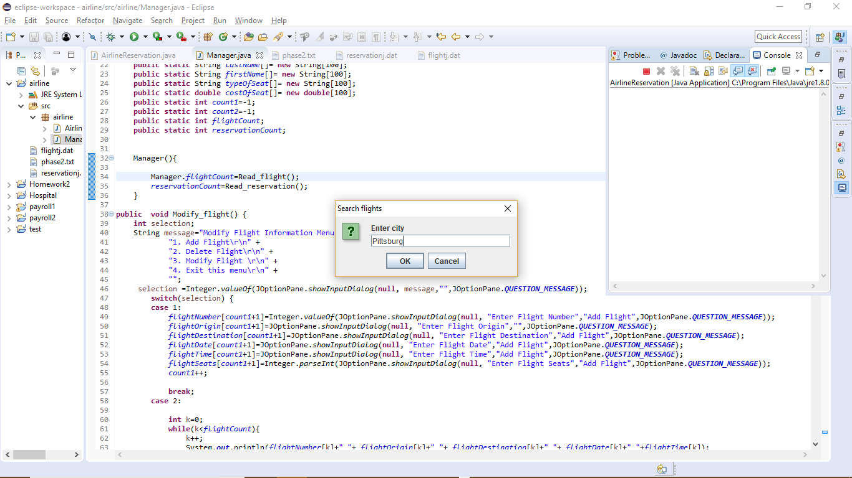
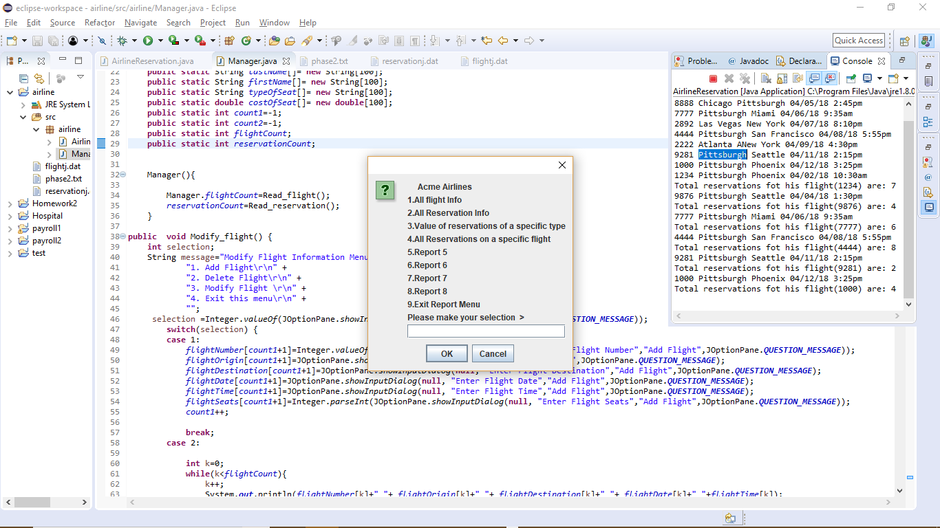
Report 6
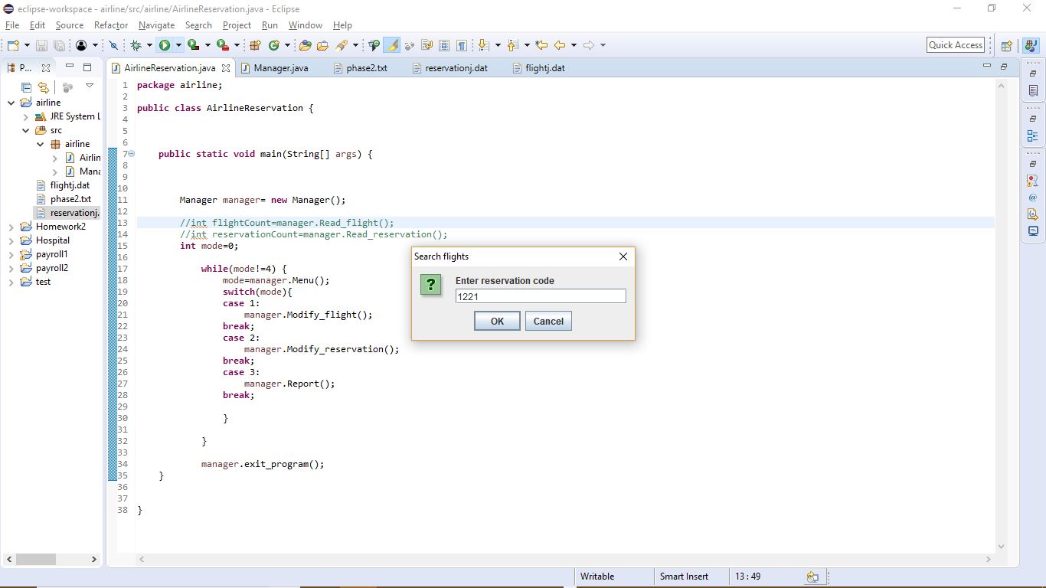
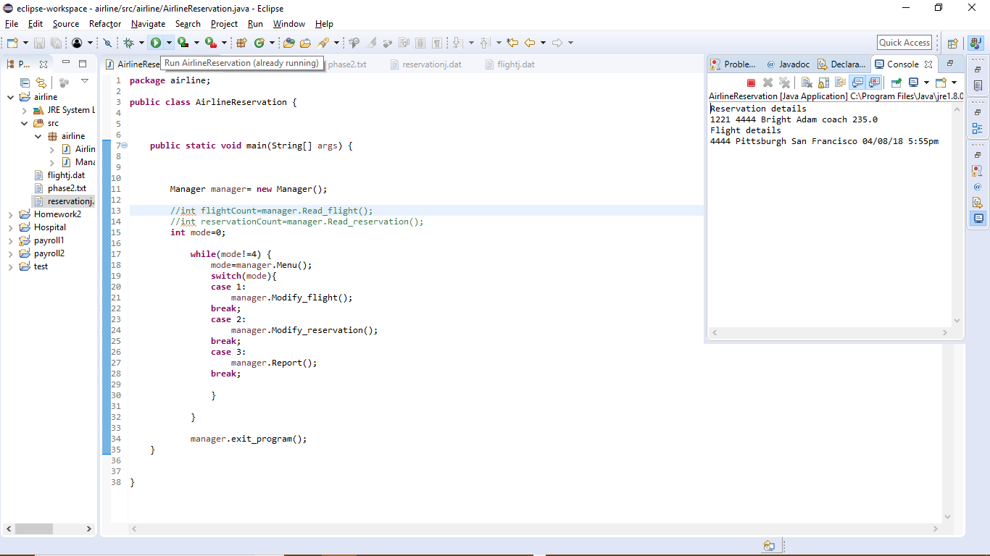
Report 7
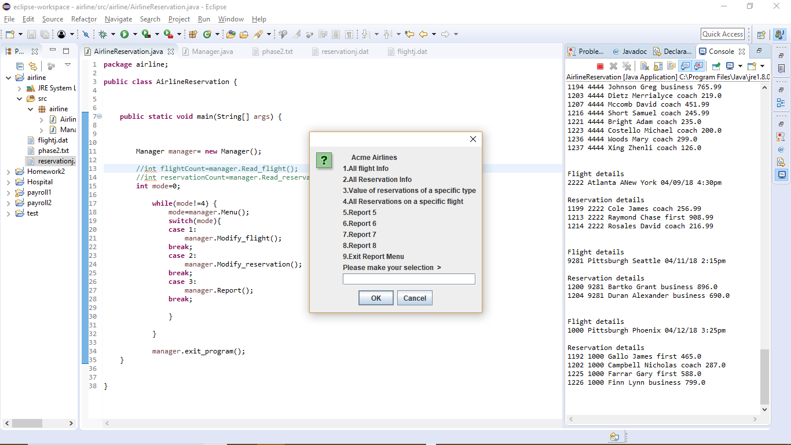
Report 8
